Reuben Dip in a Bread Bowl
Posted on January 24, 2013 by Jean Gritt
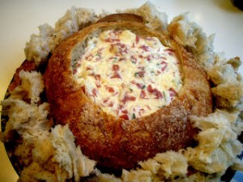Ingredients:
1 round loaf rye bread
1 cup mayonnaise
8 oz. cream cheese, softened
1 cup sour cream
¼ pound corned beef, chopped
2 cups shredded Swiss cheese
1 cup sauerkraut, drained well
2 scallions, chopped
Extra sliced rye bread or crackers for dipping
Directions:
Preheat oven to 350 degrees.
Cut out top of bread and hollow out to create a bowl. Reserve removed bread for serving.
Mix all together. Mix cream cheese, and sour cream until smooth. Stir in cheese, beef and kraut. Transfer to bread bowl and wrap bread in foil, leaving dip exposed.
Bake in a preheated 350 degrees oven for 35 to 50 minutes or until bubbly. Top with scallions. Serve dip warm with bread and/or crackers for dipping.

